Introduction to Artificial Neural Networks (ANN) :

Artificial Neural Networks (ANNs) are a fundamental component of deep learning, a subfield of machine learning inspired by the human brain. ANNs are composed of interconnected nodes, or "neurons," structured in layers that process and transform data to recognize patterns and make predictions.

Key Components of an ANN:

Input Layer: Receives the raw data that will be processed.

Hidden Layers: Perform complex transformations on the input data using weights, biases, and activation functions.

Output Layer: Provides the final prediction or classification result.

Weights and Biases: Learnable parameters that are updated during training to improve the model's accuracy.

Activation Functions: Introduce non-linearity to the network, enabling it to learn complex patterns.

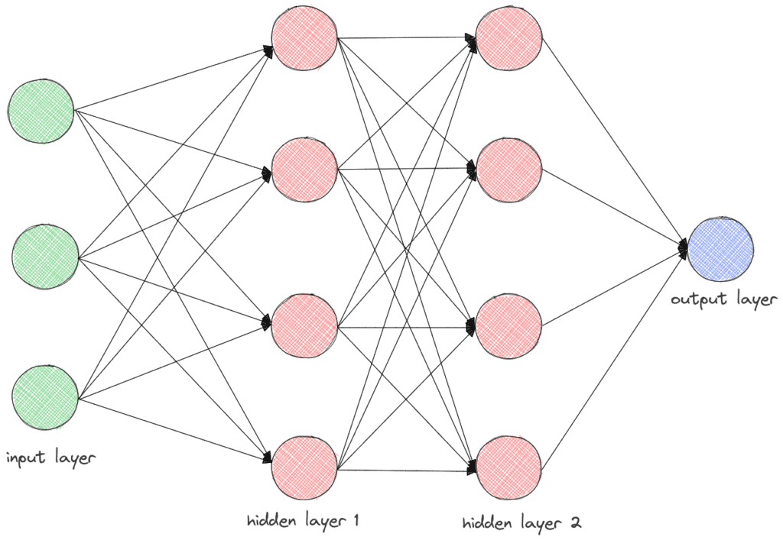

How ANNs Work:

Data Processing: Input data is fed through the network layer by layer.

Forward Propagation: Each neuron performs weighted summation followed by an activation function, passing the result to the next layer.

Error Calculation: The difference between the predicted and actual output is measured using a loss function.

Backpropagation: The error is propagated backward to adjust weights and biases, optimizing the network for better performance.

Training: The network iteratively updates its parameters through optimization techniques like gradient descent.

Applications of ANNs in Deep Learning:

Image and speech recognition

Natural language processing (NLP)

Autonomous vehicles

Medical diagnostics

Financial market predictions

The flexibility and power of ANNs have made them essential in solving complex problems and advancing AI applications.

**Types of Hidden Layers in Artificial Neural Networks**

**1. Dense (Fully Connected) Layer**

A dense layer is the most common type of hidden layer in an ANN. Every neuron in a dense layer is connected to every neuron in the previous and subsequent layers. This layer performs a weighted sum of inputs and applies an activation function to introduce non-linearity. The [activation function](https://www.geeksforgeeks.org/activation-functions-neural-networks/) (like [ReLU](https://www.geeksforgeeks.org/why-is-relu-used-as-an-activation-function/" \t "_blank), [Sigmoid](https://www.geeksforgeeks.org/derivative-of-the-sigmoid-function/), or Tanh) helps the network learn complex patterns.

**Key Points:**

* **Role**: Learns representations from input data.
* **Function**: Performs weighted sum and activation.
* **Example**: Common in fully connected neural networks.

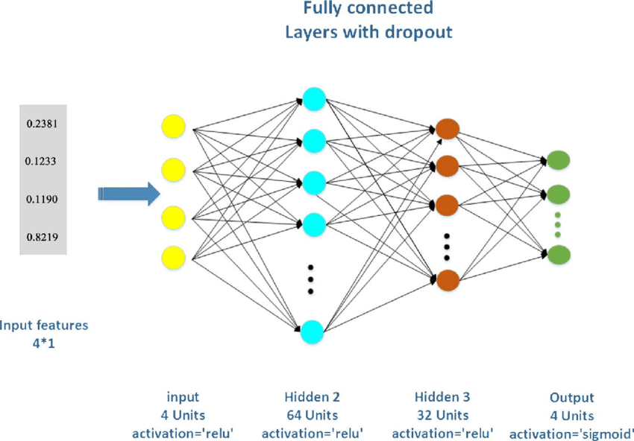

**2. Convolutional Layer**

Convolutional layers are primarily used in [Convolutional Neural Networks (CNNs)](https://www.geeksforgeeks.org/convolutional-neural-network-cnn-in-machine-learning/) for image processing tasks. They apply convolution operations to the input, capturing spatial hierarchies in the data. Convolutional layers use filters to scan across the input and generate feature maps. This helps in detecting edges, textures, and other visual features.

**Key Points:**

* **Role**: Extracts spatial features from images.
* **Function**: Applies convolution using filters.
* **Example**: Detects edges and textures in images.

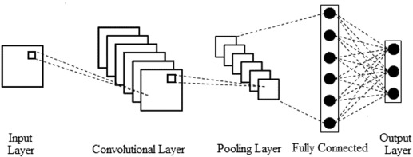

**3. Recurrent Layer**

Recurrent layers, such as [Long Short-Term Memory (LSTM)](https://www.geeksforgeeks.org/deep-learning-introduction-to-long-short-term-memory/) and [Gated Recurrent Unit (GRU),](https://www.geeksforgeeks.org/gated-recurrent-unit-networks/) are used in [Recurrent Neural Networks](https://www.geeksforgeeks.org/introduction-to-recurrent-neural-network/) (RNNs) for sequence data like time series or natural language. They have connections that loop back, allowing information to persist across time steps. This makes them suitable for tasks where context and temporal dependencies are important.

**Key Points:**

* **Role**: Processes sequential data with temporal dependencies.
* **Function**: Maintains state across time steps.
* **Example**: Language modeling, time series prediction.

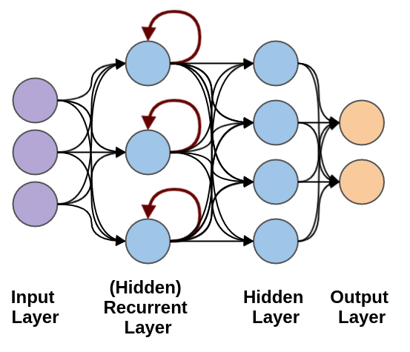

**4. Dropout Layer**

[Dropout layers](https://www.geeksforgeeks.org/dropout-in-neural-networks/) are a [regularization](https://www.geeksforgeeks.org/regularization-in-machine-learning/) technique used to prevent overfitting. They randomly drop a fraction of the neurons during training, which forces the network to learn more robust features and reduces dependency on specific neurons. During training, each neuron is retained with a probability ppp.

**Key Points:**

* **Role**: Prevents overfitting.
* **Function**: Randomly drops neurons during training.
* **Example**: Common in[deep learning](https://www.geeksforgeeks.org/deep-learning-tutorial/) models to improve generalization.

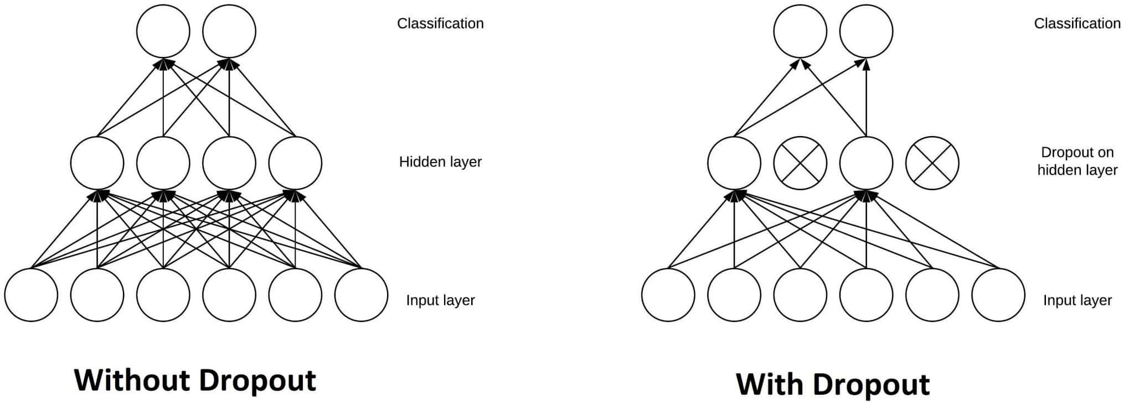

**5. Pooling Layer**

A [**Pooling Layer**](https://www.geeksforgeeks.org/cnn-introduction-to-pooling-layer/) is used to reduce the spatial dimensions of the data, thereby decreasing the computational load and controlling overfitting. Common types of pooling include Max Pooling and Average Pooling.

**Use Cases:** Dimensionality reduction in CNNs

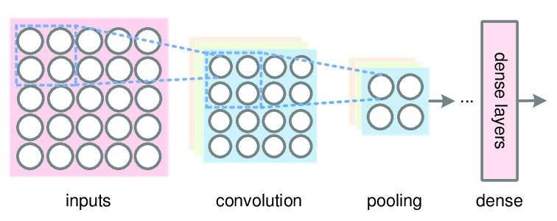

**6. Batch Normalization Layer**

A [**Batch Normalization Layer**](https://www.geeksforgeeks.org/what-is-batch-normalization-in-cnn/) normalizes the output of a previous activation layer by subtracting the batch mean and dividing by the batch standard deviation. This helps in accelerating the training process and improving the performance of the network.

**Use Cases:** Stabilizing and speeding up training

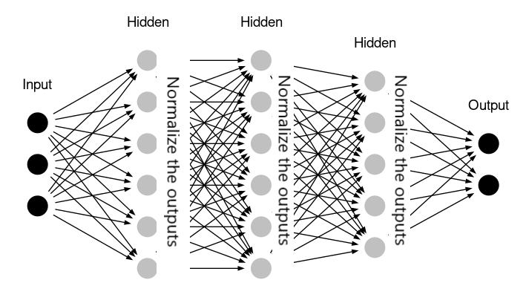

**Conclusion**

Understanding the different types of layers in an ANN is essential for designing effective neural networks. Each layer has a specific role, from receiving input data to learning complex patterns and producing predictions. By combining these layers, we can build powerful models capable of solving a wide range of tasks.

By mastering the use of input, hidden, and output layers, you can create sophisticated ANNs tailored to your specific needs, whether you're working on image recognition, natural language processing, or any other data-driven task.

**Activation Functions**

Activation functions are an integral building block of [**neural networks**](https://www.datacamp.com/blog/what-are-neural-networks) that enable them to learn complex patterns in data. They transform the input signal of a node in a neural network into an output signal that is then passed on to the next layer. Without activation functions, neural networks would be restricted to modeling only linear relationships between inputs and outputs.

Activation functions introduce non-linearities, allowing neural networks to learn highly complex mappings between inputs and outputs.

Choosing the right activation function is crucial for training neural networks that generalize well and provide accurate predictions. In this post, we will provide an overview of the most common activation functions, their roles, and how to select suitable activation functions for different use cases.

Whether you are just starting out in [**deep learning**](https://www.datacamp.com/courses/introduction-to-deep-learning-in-python) or are a seasoned practitioner, understanding activation functions in depth will build your intuition and improve your application of neural networks.

**Types of Activation Function**

**Linear Activation Function**

linear activation functions, also known as identity functions, when they want the output to be the same as the input signal. Identity is differentiable, and like a train passing through a station without stopping, this activation function doesn’t change the signal in any way, so it’s not used within internal layers of a DL network.

Although, in most cases, this might not sound very useful, it is when you want the outputs of your neural network to be continuous rather than modified or discrete. There is no convergence of data, and nothing decreases either. If you use this activation function for every layer, then it would collapse the layers in a neural network into one. So, not very useful unless that’s exactly what you need or there are different activation functions in the subsequent hidden layers.

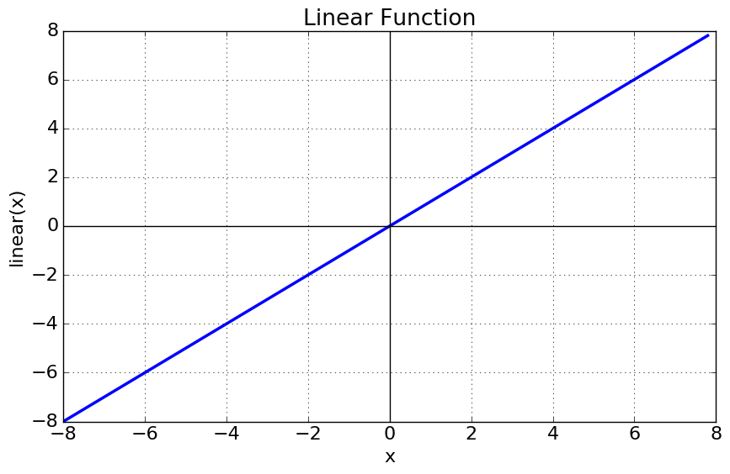

**Piecewise Linear (PL)**

Piecewise linear is an iteration on the above, except involving an [**affine function**](https://en.wikipedia.org/wiki/Affine_transformation), so it is also known as piecewise affine. It’s defined using a bound or unbound sequence of numbers, either compact, finite, or locally finite, and is not differentiable due to threshold points, so it only propagates signals in the slope region.

Piecewise linear is calculated using a range of numbers required for the particular equation, anything less than the range is 0, and anything greater is 1. Between 0 and 1, the signals going from one layer to the next are linearly-interpolated.

Here is the mathematical representation:

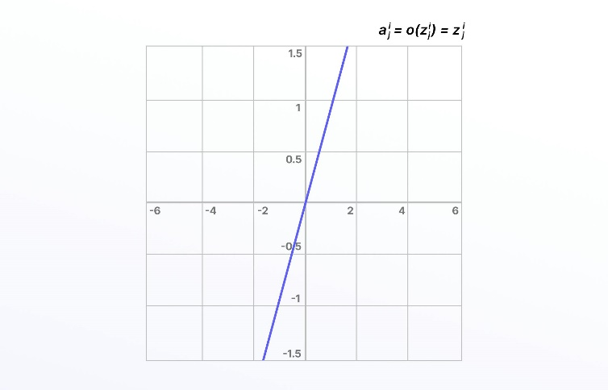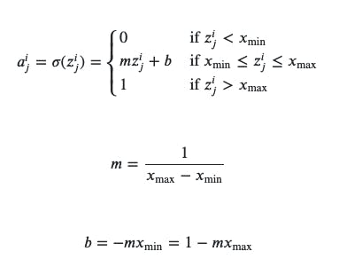

Linear activation functions don’t allow neural networks or deep learning networks to develop complex mapping and algorithmic interpretation between inputs and outputs.

**Non-Linear Activation Functions**

Non-linear activation functions solve the limitations and drawbacks of simpler activation functions, such as the vanishing gradient problem. Non-linear functions, such as **Sigmoid, Tanh, Rectified Linear Unit (ReLU)**, and numerous others.

There are several advantages to using non-linear activation functions, as they can facilitate backpropagation and stacking. Non-linear combinations and functions used throughout a network mean that data scientists and machine learning teams creating and training a model can adjust weights and biases, and outputs are represented as a functional computation.

In other words, everything going into, through, and out of a neural network can be measured more effectively when non-linear activation functions are used, and therefore, the equations are adjusted until the right outputs are achieved.

**1. Sigmoid Function**

[**Sigmoid Activation Function**](https://www.geeksforgeeks.org/derivative-of-the-sigmoid-function/) is characterized by ‘S’ shape. It is mathematically defined asA=11+e−x*A*=1+*e*−*x*1​​. This formula ensures a smooth and continuous output that is essential for gradient-based optimization methods.

* It allows neural networks to handle and model complex patterns that linear equations cannot.
* The output ranges between 0 and 1, hence useful for binary classification.
* The function exhibits a steep gradient when x values are between -2 and 2. This sensitivity means that small changes in input x can cause significant changes in output y, which is critical during the training process.

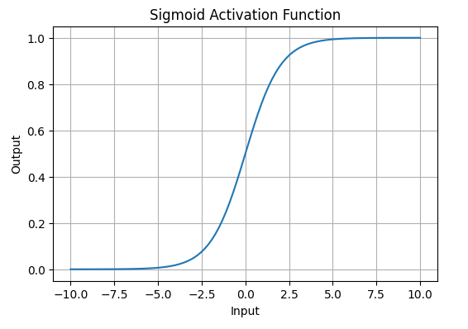

*Sigmoid or Logistic Activation Function Graph*

**2. Tanh Activation Function**

Tanh function or hyperbolic tangent function**,** is a shifted version of the sigmoid, allowing it to stretch across the y-axis. It is defined as:

f(x)=tanh⁡(x)=21+e−2x–1.*f*(*x*)=tanh(*x*)=1+*e*−2*x*2​–1.

Alternatively, it can be expressed using the sigmoid function:

tanh⁡(x)=2×sigmoid(2x)–1tanh(*x*)=2×sigmoid(2*x*)–1

* **Value Range**: Outputs values from -1 to +1.
* **Non-linear**: Enables modeling of complex data patterns.
* **Use in Hidden Layers**: Commonly used in hidden layers due to its zero-centered output, facilitating easier learning for subsequent layers.

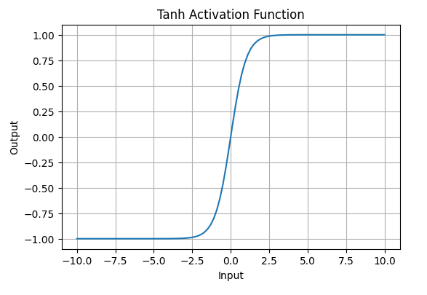

*Tanh Activation Function*

**3. ReLU (Rectified Linear Unit) Function**

[**ReLU activation**](https://www.geeksforgeeks.org/relu-activation-function-in-deep-learning/) is defined by A(x)=max⁡(0,x)*A*(*x*)=max(0,*x*), this means that if the input x is positive, ReLU returns x, if the input is negative, it returns 0.

* **Value Range**: [0,∞)[0,∞), meaning the function only outputs non-negative values.
* **Nature**: It is a **non-linear** activation function, allowing neural networks to learn complex patterns and making backpropagation more efficient.
* **Advantage over other Activation:**ReLU is less computationally expensive than tanh and sigmoid because it involves simpler mathematical operations. At a time only a few neurons are activated making the network sparse making it efficient and easy for computation.

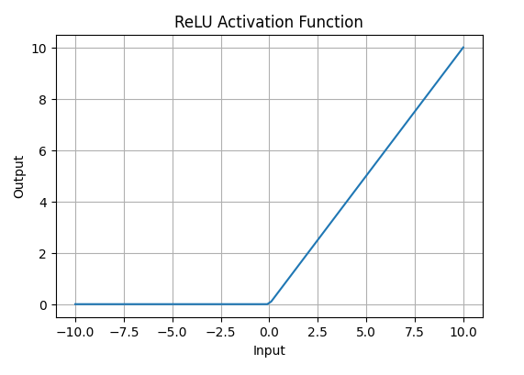

*ReLU Activation Function*

**Leaky ReLU Function**

One solution to the “dying ReLU” problem is a variation on this known as the Leaky ReLU activation function. With the Leaky ReLU, instead of being 0 when *𝑧*<0, a leaky ReLU allows a small, non-zero, constant gradient *𝛼*(Normally, *𝛼*=0.01).

Here is the mathematical representation: 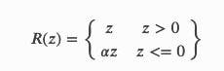

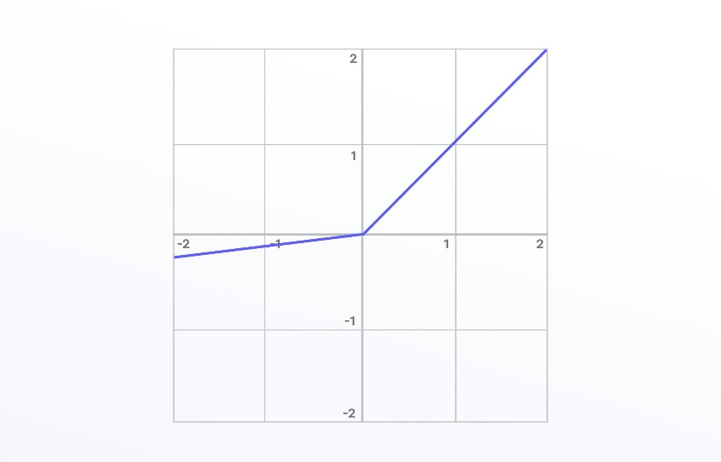

Leaky ReLU has been shown to perform better than the traditional ReLU activation function. However, because it possesses linearity it can’t be used for more complex classification tasks and lags behind more advanced activation functions such as Sigmoid and Tanh.

**Optimizers**

**Optimizers** are algorithms or methods used to minimize an error function(*loss function*)or to maximize the efficiency of production. Optimizers are mathematical functions which are dependent on model’s learnable parameters i.e Weights & Biases. Optimizers help to know how to change weights and learning rate of neural network to reduce the losses.

***TYPES OF OPTIMIZERS :***

1. Gradient Descent
2. Stochastic Gradient Descent
3. Adagrad
4. Adadelta
5. RMSprop
6. Adam

G***radient Descent***

This is one of the oldest and the most common optimizer used in neural networks, best for the cases where the data is arranged in a way that it possesses a convex optimization problem. It will try to find the least cost function value by updating the weights of your learning algorithm and will come up with the best-suited parameter values corresponding to the Global Minima.

This is done by moving down the hill with a negative slope, increasing the older weight, and positive slope reducing the older weight.

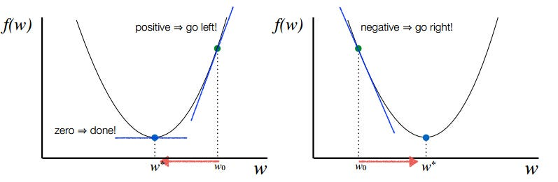



Finding the global minima for a convex optimization problem using Gradient Descent

S***tochastic Gradient Descent***

This is another variant of the Gradient Descent optimizer with an additional capability of working with the data with a non-convex optimization problem. The problem with such data is that the cost function results to rest at the local minima which are not suitable for your learning algorithm.

Rather than going for batch processing, this optimizer focuses on performing one update at a time. It is therefore usually much faster, also the cost function minimizes after each iteration (EPOCH). It performs frequent updates with a high variance that causes the objective function(cost function) to fluctuate heavily. Due to which it makes the gradient to jump to a potential Global Minima.

However, if we choose a learning rate that is too small, it may lead to very slow convergence, while a larger learning rate can make it difficult to converge and cause the cost function to fluctuate around the minimum or even to diverge away from the global minima.



Converging at the global minima using SGD for non-convex data

A***dagrad***

This is the Adaptive Gradient optimization algorithm, where the learning rate plays an important role in determining the updated parameter values. Unlike Stochastic Gradient descent, this optimizer uses a different learning rate for each iteration(EPOCH) rather than using the same learning rate for determining all the parameters.

Thus it performs smaller updates(lower learning rates) for the weights corresponding to the high-frequency features and bigger updates(higher learning rates) for the weights corresponding to the low-frequency features, which in turn helps in better performance with higher accuracy. Adagrad is well-suited for dealing with sparse data.

So at each iteration, first the alpha at time t will be calculated and as the iterations increase the value of t increases, and thus alpha t will start increasing.



A***dadelta***

This is an extension of the Adaptive Gradient optimizer, taking care of its aggressive nature of reducing the learning rate infinitesimally. Here instead of using the previous squared gradients, the sum of gradients is defined as a reducing weighted average of all past squared gradients(weighted averages) this restricts the learning rate to reduce to a very small value.

The formula for the new weight remains the same as in Adagrad. However, there are some changes in determining the learning rate at time step t for each iteration.

At each iteration, first the weighted average is calculated. Where we have the restricting term(gamma = 0.95) which helps in avoiding the problem of [*Vanishing Gradient*](https://en.wikipedia.org/wiki/Vanishing_gradient_problem).

R***MSprop***

Both the optimizing algorithms, RMSprop(Root Mean Square Propagation) and Adadelta were developed around the same time, for the same purpose to resolve Adagrad’s problem of destructive learning rates. However, both use the same method which utilizes an Exponential Weighted Average to determine the learning rate at time t for each iteration.

RMSprop is an adaptive learning rate method proposed by Geoffrey Hinton, which appropriately divides the learning rate by an exponentially weighted average of squared gradients. It is suggested to set gamma at 0.95, as it has been showing good results for most of the cases.

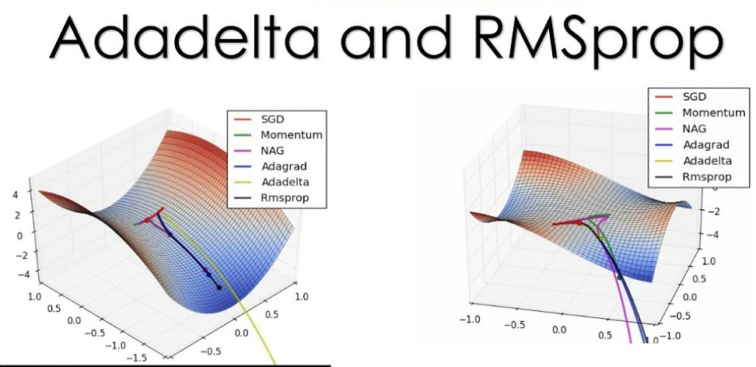

A***dam***

This is the Adaptive Moment Estimation algorithm which also works on the method of computing adaptive learning rates for each parameter at every iteration. It uses a combination of [*Gradient Descent with Momentum*](https://engmrk.com/gradient-descent-with-momentum/) and RMSprop to determine the parameter values.

When introducing the algorithm, there was a list of attractive benefits of using Adam on non-convex optimization problems which made it the most commonly used optimizer.

It comes with several advantages combining the benefits of both Gradient with Momentum and RMSProp like low memory requirements, appropriate for non-stationary objectives, works best with large data and parameters with efficient computation. This works using the same methodology of adaptive learning rate in addition to storing an exponential weighted average of the past squared derivative of loss with respect to the weight at time t-1.

It comes with several parameters, which are β1, β2, and ε (epsilon). Where β1 and β2 are the initial restricting parameters for Momentum and RMSprop respectively. Here, β1 corresponds to the first moment and β2 corresponds to the second moment.

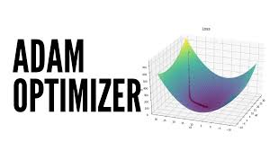

**Autoencoder**

An **autoencoder** is a type of artificial neural network used for unsupervised learning, primarily designed for tasks like dimensionality reduction, feature learning, and data compression. The core idea behind an autoencoder is to learn an efficient representation of input data by compressing it into a lower-dimensional space (called the **latent space**) and then reconstructing the original data as accurately as possible.

The autoencoder consists of two main components:

1. **Encoder**: The encoder maps the input data to a lower-dimensional latent space. It captures the most important features of the input while reducing its size.
2. **Decoder**: The decoder takes the compressed representation from the latent space and attempts to reconstruct the original input data. The goal is to minimize the difference between the input and the output, often using a loss function like mean squared error.

Autoencoders are useful for a wide range of applications, including anomaly detection, image denoising, and feature extraction. More advanced versions, such as **variational autoencoders (VAEs)**, also have generative capabilities, enabling them to create new data samples similar to the original data.

Because they learn a compressed and often more meaningful representation of the data, autoencoders can improve the efficiency and performance of machine learning models, particularly in high-dimensional data tasks like image or text processing.

**Types of Encoders**

**1) Denoising Autoencoder**

Denoising autoencoders create a corrupted copy of the input by introducing some noise. This helps to avoid the autoencoders to copy the input to the output without learning features about the data. These autoencoders take a partially corrupted input while training to recover the original undistorted input. The model learns a vector field for mapping the input data towards a lower dimensional manifold which describes the natural data to cancel out the added noise.

Advantages-

* It was introduced to achieve good representation. Such a representation is one that can be obtained robustly from a corrupted input and that will be useful for recovering the corresponding clean input.
* Corruption of the input can be done randomly by making some of the input as zero. Remaining nodes copy the input to the noised input.
* Minimizes the loss function between the output node and the corrupted input.
* Setting up a single-thread denoising autoencoder is easy.

Drawbacks-

* To train an autoencoder to denoise data, it is necessary to perform preliminary stochastic mapping in order to corrupt the data and use as input.
* This model isn't able to develop a mapping which memorizes the training data because our input and target output are no longer the same.

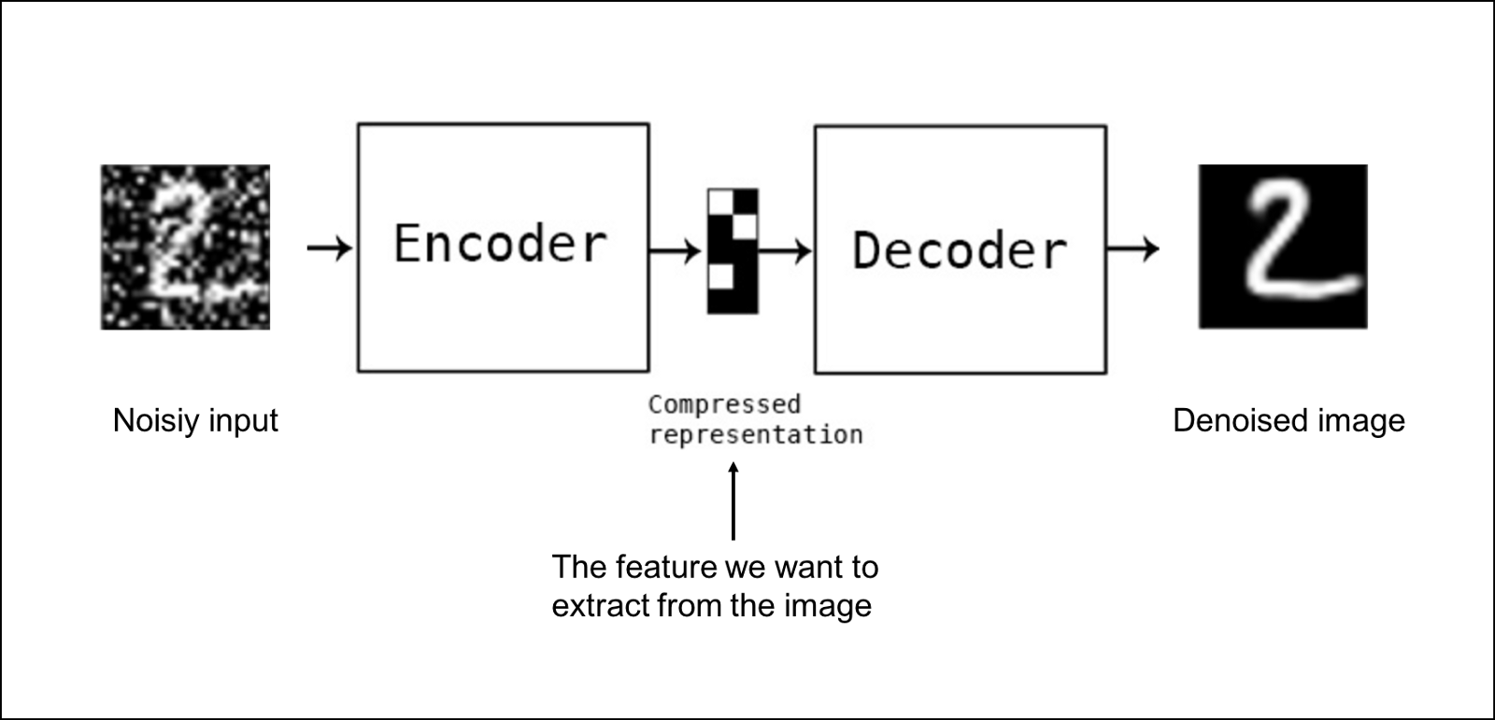

**2) Sparse Autoencoder**

Sparse autoencoders have hidden nodes greater than input nodes. They can still discover important features from the data. A generic sparse autoencoder is visualized where the obscurity of a node corresponds with the level of activation. Sparsity constraint is introduced on the hidden layer. This is to prevent output layer copy input data. Sparsity may be obtained by additional terms in the loss function during the training process, either by comparing the probability distribution of the hidden unit activations with some low desired value,or by manually zeroing all but the strongest hidden unit activations. Some of the most powerful AIs in the 2010s involved sparse autoencoders stacked inside of deep [neural networks](https://iq.opengenus.org/types-of-autoencoder/).

Advantages-

* Sparse autoencoders have a sparsity penalty, a value close to zero but not exactly zero. Sparsity penalty is applied on the hidden layer in addition to the reconstruction error. This prevents overfitting.
* They take the highest activation values in the hidden layer and zero out the rest of the hidden nodes. This prevents autoencoders to use all of the hidden nodes at a time and forcing only a reduced number of hidden nodes to be used.

Drawbacks-

* For it to be working, it's essential that the individual nodes of a trained model which activate are data dependent, and that different inputs will result in activations of different nodes through the network.

**3) Deep Autoencoder**

Deep Autoencoders consist of two identical deep belief networks, oOne network for encoding and another for decoding. Typically deep autoencoders have 4 to 5 layers for encoding and the next 4 to 5 layers for decoding. We use unsupervised layer by layer pre-training for this model. The layers are Restricted Boltzmann Machines which are the building blocks of deep-belief networks. Processing the benchmark dataset MNIST, a deep autoencoder would use binary transformations after each RBM. Deep autoencoders are useful in topic modeling, or statistically modeling abstract topics that are distributed across a collection of documents. They are also capable of compressing images into 30 number vectors.

Advantages-

* Deep autoencoders can be used for other types of datasets with real-valued data, on which you would use Gaussian rectified transformations for the RBMs instead.
* Final encoding layer is compact and fast.

Drawbacks-

* Chances of overfitting to occur since there's more parameters than input data.
* Training the data maybe a nuance since at the stage of the decoder’s backpropagation, the learning rate should be lowered or made slower depending on whether binary or continuous data is being handled.

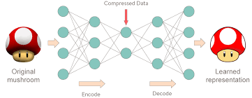

**4) Contractive Autoencoder**

The objective of a contractive autoencoder is to have a robust learned representation which is less sensitive to small variation in the data. Robustness of the representation for the data is done by applying a penalty term to the loss function. Contractive autoencoder is another regularization technique just like sparse and denoising autoencoders. However, this regularizer corresponds to the Frobenius norm of the Jacobian matrix of the encoder activations with respect to the input. Frobenius norm of the Jacobian matrix for the hidden layer is calculated with respect to input and it is basically the sum of square of all elements.

Advantages-

* Contractive autoencoder is a better choice than denoising autoencoder to learn useful feature extraction.
* This model learns an encoding in which similar inputs have similar encodings. Hence, we're forcing the model to learn how to contract a neighborhood of inputs into a smaller neighborhood of outputs.

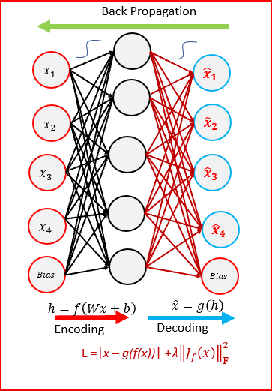

**5) Undercomplete Autoencoder**

The objective of undercomplete autoencoder is to capture the most important features present in the data. Undercomplete autoencoders have a smaller dimension for hidden layer compared to the input layer. This helps to obtain important features from the data. It minimizes the loss function by penalizing the g(f(x)) for being different from the input x.

Advantages-

* Undercomplete autoencoders do not need any regularization as they maximize the probability of data rather than copying the input to the output.

Drawbacks-

* Using an overparameterized model due to lack of sufficient training data can create overfitting.

**6) Convolutional Autoencoder**

Autoencoders in their traditional formulation does not take into account the fact that a signal can be seen as a sum of other signals. Convolutional Autoencoders use the convolution operator to exploit this observation. They learn to encode the input in a set of simple signals and then try to reconstruct the input from them, modify the geometry or the reflectance of the image. They are the state-of-art tools for unsupervised learning of convolutional filters. Once these filters have been learned, they can be applied to any input in order to extract features. These features, then, can be used to do any task that requires a compact representation of the input, like classification.

Advantages-

* Due to their convolutional nature, they scale well to realistic-sized high dimensional images.
* Can remove noise from picture or reconstruct missing parts.

Drawbacks-

* The reconstruction of the input image is often blurry and of lower quality due to compression during which information is lost.

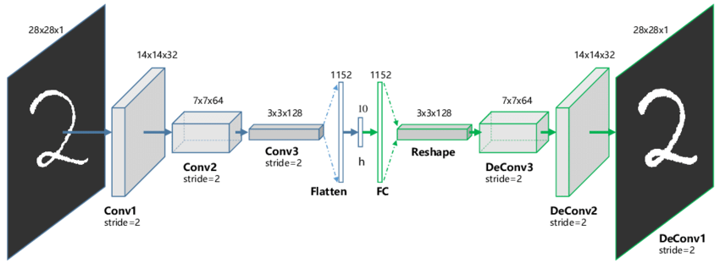

**7) Variational Autoencoder**

Variational autoencoder models make strong assumptions concerning the distribution of latent variables. They use a variational approach for latent representation learning, which results in an additional loss component and a specific estimator for the training algorithm called the Stochastic Gradient Variational Bayes estimator. It assumes that the data is generated by a directed graphical model and that the encoder is learning an approximation to the posterior distribution where Ф and θ denote the parameters of the encoder (recognition model) and decoder (generative model) respectively. The probability distribution of the latent vector of a variational autoencoder typically matches that of the training data much closer than a standard autoencoder.

Advantages-

* It gives significant control over how we want to model our latent distribution unlike the other models.
* After training you can just sample from the distribution followed by decoding and generating new data.

Drawbacks-

* When training the model, there is a need to calculate the relationship of each parameter in the network with respect to the final output loss using a technique known as backpropagation. Hence, the sampling process requires some extra attention.

